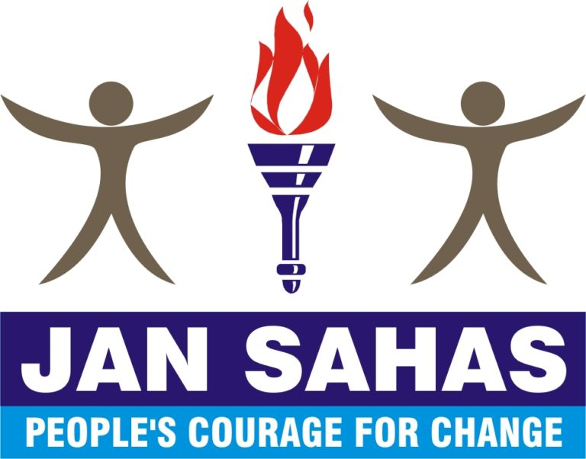

Job Description - Manager, Grassroots Resilience Institute
Hiring for | Manager, Grassroots Resilience Institute
Report to | Head, GRI
Location | Delhi, preferred.
Travel | Yes. 10-12 days a month for partner visits, workshops and meetings
Annual CTC | Competitive compensation and benefits package (commensurate based on experience)
Apply by | Immediately, the recruitment process will be ongoing till the final candidate is selected
For queries write to | careers@jansahasindia.org

About Jan Sahas
About the organization Jan Sahas, established in the year 2000, is a not for profit grassroots organization committed to promote the development and protect the rights of socially excluded communities with the special focus on girls and women through eradication of all forms of bondage including manual scavenging and caste-based prostitution; empowerment of adolescent girls and women to end violence and gender justice, skill development for dignified livelihoods and social entrepreneurship; legal aid for access to justice and reform in the criminal justice system; land and agriculture development; develop barefoot lawyers to build victim or survivors as leader and empowerment of communities through capacity and organization building. With our national office in New Delhi. We are currently working in ~100 districts of 13 states in India. To know more please visit at: https://jansahas.org

About GRI
India has nearly 3.4 million civil society organizations that are working in a variety of fields ranging from disaster relief to advocacy for marginalized and disadvantaged communities. Despite being crucial to India’s development delivery, grassroot organizations lack the resources and capacity to sustain their work. According to a report on India’s philanthropic landscape by Bain & Company, there was a ~40% decline in foreign funding between 2015 and 2018. CBOs face an increasingly difficult ecosystem to grow and thrive.

First, with the Covid-19 pandemic, a lot of funding has been diverted to health and related services. In addition, the pandemic has impacted their workforce and the economic status of their constituents.

Second, recent regulatory changes have reduced the funding scope of such grassroots nonprofits. With increased financial constraints, organizations are compelled to cut back on programs, lay off employees and face the very real question of survival.

At Jan Sahas, we believe that community organizations need to be strengthened and supported and helped to grow for not just scaling Jan Sahas’ own mission of empowering marginalized communities, but also together creating a robust ecosystem for social sector leaders in India.

Our prior experience in incubating and capacity building for 20 partner organizations under the program “Dignity Collective for Capacity and Institution Building of the Community Based Organizations (CBOs) of Socially Excluded Communities” forms the basis for our ambition.

Jan Sahas started GRI in 2022 to institutionalize its work in partnering with mission-aligned grassroots organizations and aims to support 100 community-based organizations under this initiative over the next 5 years.

GRI Goals:
- To partner with grassroots organizations and support their growth towards the advancement of work with communities Jan Sahas works closely with (women, SC/ST, and other minorities and particularly vulnerable groups) and on topics that Jan Sahas is closely aligned with (safe migration, prevention of violence)
- To augment the organizational development of civil society organizations towards a resilient civil society
- To scale the existing mission of Jan Sahas’ work through building multiple, diverse community-based organizations

To do this, Jan Sahas expects to provide support through:
- Direct program partnership with Jan Sahas core themes of migration and gender violence, with specific program themes

- Organizational development support, primarily through GRI
- Fellowship support to changemakers to ideate and launch organizations/collectives, through GRI

Under GRI, Jan Sahas will partner with grassroots nonprofits to provide support on overall organizational development, covering key elements such as compliance (legal & financial), fundraising as well as supporting the development of program clarity.

Key responsibilities and KPIs
The following responsibilities will be driven by the Head, and supported by the Program Managers. Managers are expected to assist in thought partnership as well as drive the execution. The major aspects of the role of the Managers are:

- Strategy & Business Plan: Support role
  - Support the co-creation of strategic goals, objectives, outcomes and targets for the next 3 years, in alignment with organizational goals
  - Create, refine and own the management plan for achieving GRI’s outcomes for all partners
  - Co-create GRI initiative’s KRAs in line with team KRAs

- Operational Management: Direct role
  - With partner CBOs:
    - Review and input on action plans for all partner CBOs
    - Provide 1:1 organisation and leadership support as and when required
    - Drive the production of training modules on building program clarity, fundraising, financial management, with support from the team and independent experts
    - Work closely with the partner CBOs to deliver proposed outcomes
  - Within Jan Sahas:
    - Manage internal communications and donor reporting
    - Identify and institutionalize suitable governance and management structures (i.e., reporting to Board/Advisors, instituting an advisory group, getting support from other teams, etc)

- Fundraising: Support role
  - Support on fundraising strategy needed to sustain the program for 3-5 years in line with the fundraising team
  - Support on building fundraising collateral, fundraising outreach and building relationships with relevant stakeholders

- Learning & Innovation: Direct role
  - Identify key learning questions, open questions and critical questions for program success
  - Foster a culture of flexible and open learning with reports/insights for strategic review and learning on a regular basis

Core skills / ideal qualification and experience

We’re looking for individuals passionate about leveraging their skill sets to maximize Jan Sahas’ ability to create an impact for millions of vulnerable Indians. We are in search of people who possess a strong execution bias and are critical thinkers with a high degree of resilience.

- Prior management experience of 5-7 years, with at least ~1 years of managing and working with multiple stakeholders such as donors/community-based organizations, donors and non-profit programs
- Experience in working with and knowledge of the challenges and opportunities for grassroots organizations in India
- Enthusiastic, self-starter, ready to roll up your sleeves and solve problems
- Keen to experiment and open to learning from failure, iterating on program design and delivery
- A strong sense of appreciation for challenges facing excluded and low-income communities in India.
- Strong written and verbal communication skills in English. Fluent in Hindi, and able to deliver workshops in Hindi as needed. Other language skills are a plus.

Compensation and benefits
We offer competitive compensation and benefits package.
Annual CTC: Commensurate with experience, skills etc.

Benefits:
- Health Insuranc
- Term-life Insurance
- A total of 25 days of annual, casual and sick leave. Additional 6 days of menstrual leave
- Maternity leave (as per law), paternity leave
- Employee Assistance Program / mental health support

Application Process
Interested applicants can email careers@jansahasindia.org with the subject “Manager, GRI”. Applicants must attach their CV and cover letter addressing their interest in the role to be considered eligible. The full process includes 1 assignment and 3-5 interviews with leaders in the organization.

